**Fatimah Sohail Shaukat**

**2020-CE-37**

CN Lab – 2

# Question 1:

United States:

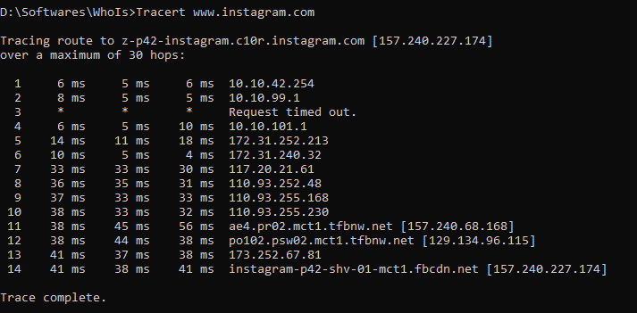

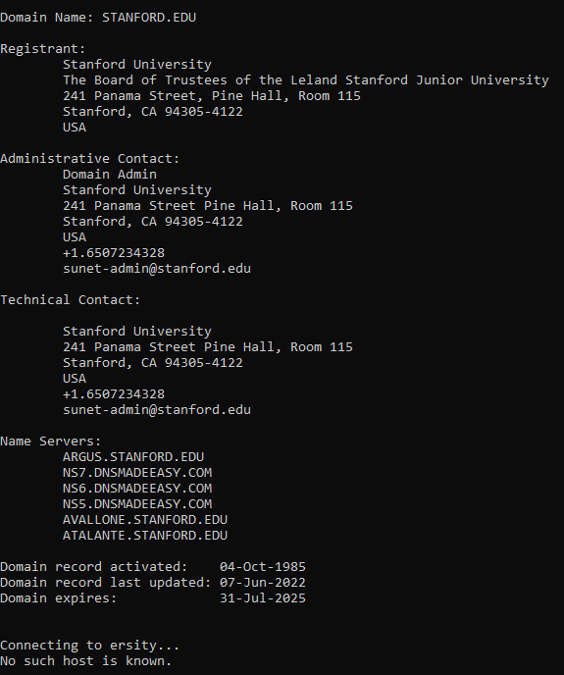

Europe:

Snapchat

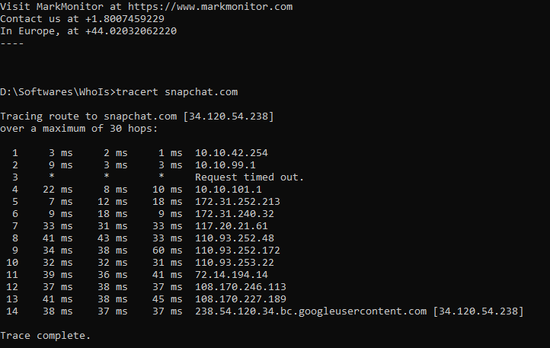

Mexico - University of Mexico

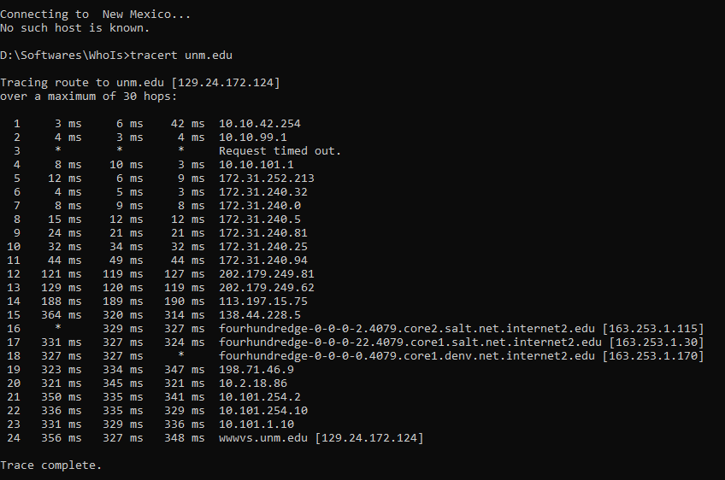

Sydney:

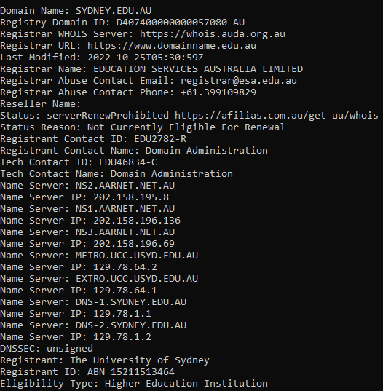

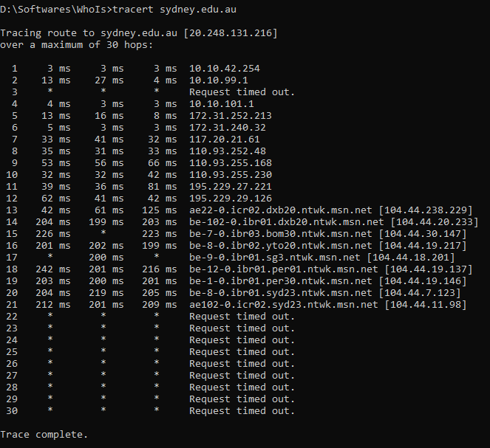

Dubai:

Canadian University Dubai

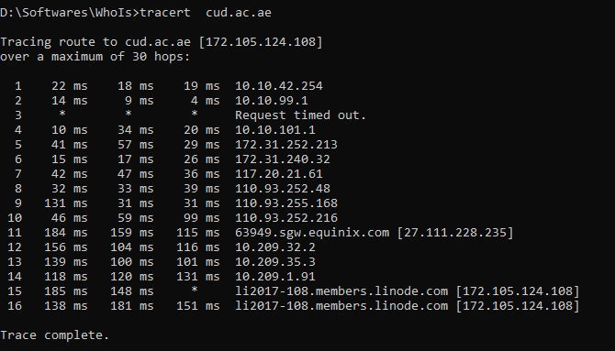

Berlin- Germany:

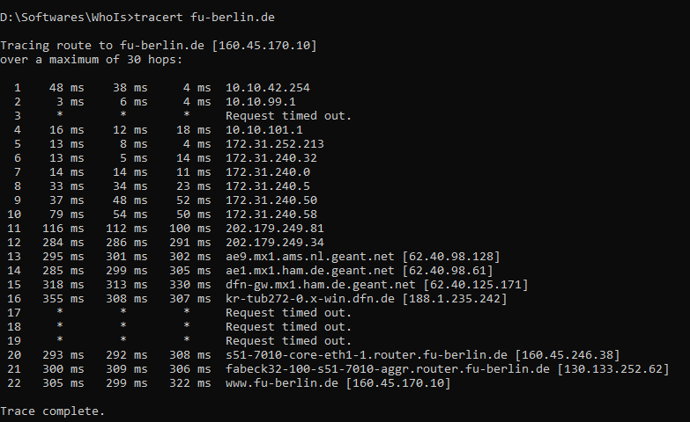

New Zealand:

The University of Waikato

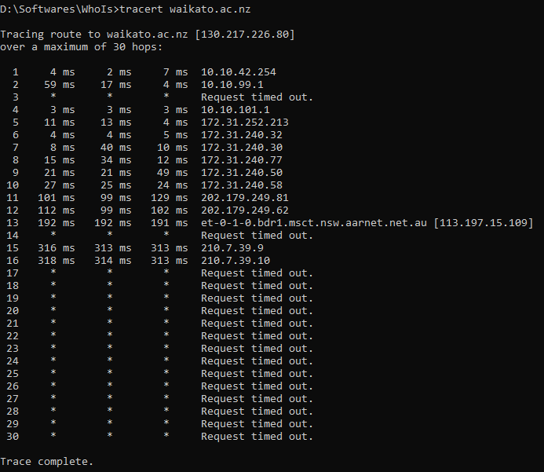

# Question 2:

Before talking about the behavior of traceroute, let’s see some important cases. If we encounter:

* means that your machine received no response.
* !H means that your machine received ICMP message "destination host unreachable" from the host indicated in the traceroute output.
* Rarely traceroute can indicate also other unreachable messages like !N or !P (network or protocol) etc.

Following are the three different observations about behavior of traceroute including abnormal output or unexpected behavior:

1. Tracert will keep going until it reaches 30 hop counts. Your screenshot shows that it entered the blocked area where request packets are ignored.

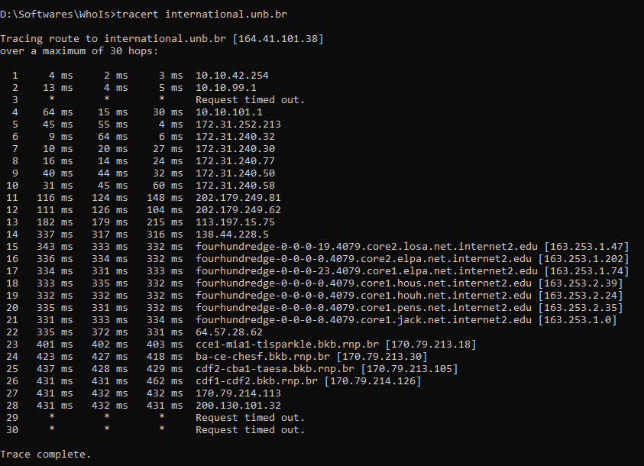

1. We might see another situation where some packets in the middle are timedout, and it replies after that. It depends on the device that receives the request packet from your client.

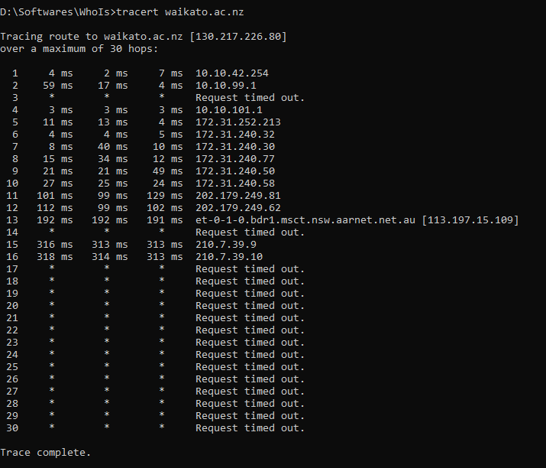

1. Tracert command increases TTL by one unit to reach further device on the path, if that device blocks or doesn't answer your ICMP Request, you got the timedout message. Next step, your tracert command will try another router behind the previous one. At each steps, it totally depends on the destination router.

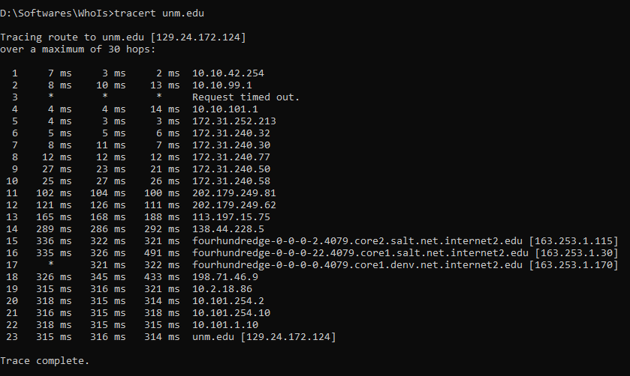

# Question 3:

Traceroute is a standard utility on virtually all TCP/IP−enabled operating systems. This program sends out a sequence of IP packets to and from nodes along the route from your computer to the designated machine. A traceroute from University of Engineering and Technology to a node at the University of Hawaii.

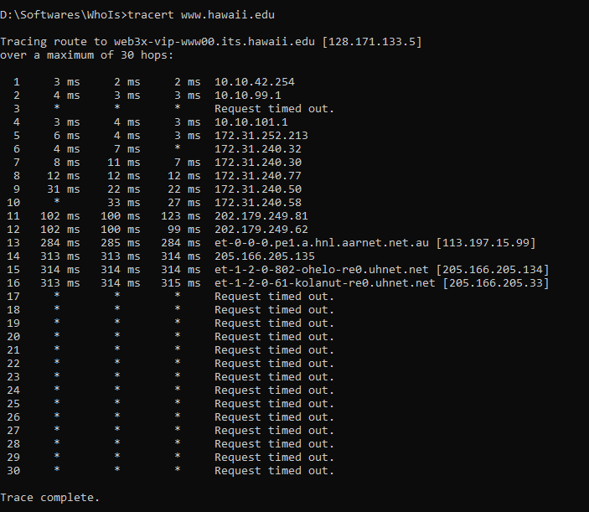 The output of each line indicates the round−trip time for each independent packet to and from a node on the way to Hawaii. The route chosen in this case is through Pakistan, China, to Hawaii. Signals traversed from China to Hawaii through an oceanic fiber optic cable. As clear from the above screenshot, time taken for a packet to get from China to Hawaii is 24.4 ms. The speed of light in the glass cable (fiber optic) is about 2/3 of that in vacuum. So using the relation:

d = vt

d = (2/3 x 3 x 108 m/s ) x (24.4 x 10−3 s)

d = 4800 Km

This is the estimate of the cable distance. Assuming that the radius of classroom globe is 15.3 cm along the surface of the globe to be about 10.4 cm long, yielding an estimate of the earth radius of

15.3 * 4800 / 10.4 = **7100 Km**. So, ***the diameter of Earth is 7100/2 = 3550 km.***

# References:

1. <https://arxiv.org/pdf/physics/0208087.pdf>